Jim Pickles
Posture and Flexibility

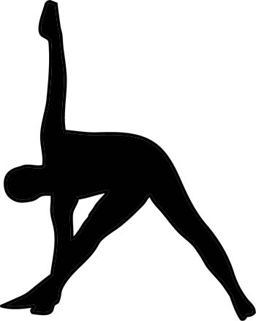

Name:

Phone No:

Email address:
Are you willing to receive class information by email and/or text message? Yes/No

Street address:

Emergency contact information:

Recent exercise undertaken:

Do you have any medical issues that I should know about? I particularly need to know whether you have been advised against taking the head below the level of the heart, about any problems with the neck, and about any problems with the knees. Please also keep me informed about any changes. Please list if applicable:

Any medical issues should be dealt with by a qualified medical professional, who needs to agree to your participation in an exercise programme consisting of relaxation, core strengthening, stretching, postural alignment and meditation.

Do you have any areas of concern (as distinct from the medical issues listed above)? (e.g. tension in shoulders, neck, etc):

The above information is required to assess the suitability of the exercise programme. The information will be treated with the strictest confidence and will not be disclosed to third parties without the participant’s consent.

I confirm the above details. I understand that it is my responsibility to apply the techniques only to the extent that they are appropriate and comfortable for me.

Signed:

Date:

Contact details:
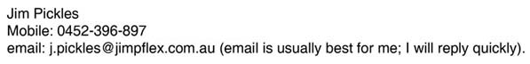
The webpage www.jimpflex.com.au has further details of the classes.

